Surrounding Communities
As part of the planning process, it is vital to ensure that the plans are consistent with the plans of the surrounding municipalities. Therefore, the following describes the municipalities and counties that border the Mercersburg Area and examines the plans for the adjacent communities to assure consistency with the Mercersburg Area Comprehensive Plan.
Geographic Location Context
The Mercersburg Area (Mercersburg Borough, Peters Township and Montgomery Township) are situated in the southwest corner of Franklin County, sharing its western boundary with Fulton County Pennsylvania, and its southern boundary with Washington County, Maryland. The following is a summary of the boarders of the municipalities within the Mercersburg Area.
Mercersburg Borough
Mercersburg Borough’s borders are shared with both Townships in the Mercersburg Area, Peters Township to the north and Montgomery Township to the south.
Peters Township
Peters Township is situated to the north of Mercersburg Borough and shares its borders with a number of municipalities. To the north Metal Township and St. Thomas Township share their borders with Peters Township. The eastern border is shared with Antrim Township, to the south is Mercersburg Borough, Montgomery Township and Warren Township. The western border of Peters Township is shared with Ayr Township and Todd Township, which are both Fulton County municipalities.
Montgomery Township
Montgomery Township borders some of the same municipalities as Peters Township. To the north the Township borders Mercersburg Borough and Peters Township. To the east the Township borders Antrim Township, and to the west the Township borders Warren Township. The southern boundary of Montgomery Township is also shared by the boundary of the State. Therefore, the southern boundary of the Township boarders Washington County, Maryland.
Surrounding Community Planning
When looking at the planning and zoning of the surrounding communities, a majority of the communities do not have their own comprehensive plans and or zoning, therefore County Comprehensive Plans were largely assessed for consistency.
Municipality (Pennsylvania Communities) | Municipal Comprehensive Plan | Zoning | SALDO
Metal Township (Franklin County) | No | No | Yes
St. Thomas Township (Franklin County) | No | No | Unsure
Antrim Township (Franklin County) | Yes - Joint Comprehensive Plan | Yes (Zoning Map Only) | Yes
Warren Township (Franklin County) | No | No | Yes
Ayr Township (Fulton County) | No | No | Yes
Todd Township (Fulton County) | No | No | Yes
Franklin County
The Franklin County Comprehensive Plan (2023), Imagine Franklin 2035 includes a County Character Map which describes the different character areas in the County which range from urban centers to rural areas. When looking at the Mercersburg Area, the borders of the area and the adjacent municipalities within Franklin County have the same character. Mercersburg Borough is a suburban center that is surrounded by agricultural character areas, and rural areas. There is one rural center located in Peters Township. There is one area in the southeast corner of Montgomery Township, that there is a difference between the character areas, where Montgomery Township is rural and a portion of the southwest corner of Antrim Township is agricultural. The following is a brief description of the character types in the Mercersburg Area and the surrounding communities in Franklin County:
- Suburban Center - Predominantly regional centers of economic activity containing multiple land uses of varying degrees of intensity. This character area is a growth area.
- Rural Center - Rural, unincorporated villages with limited access to major infrastructure, such as public water or sewer and interstates. This character area is a growth area
- Rural - Open and wooded lands with scattered villages, farms, and residential uses. This character area is a rural resources area.
- Agricultural - Large concentrations of high-quality soils and active and diverse farm operations along with related support services. This character area is a rural resources area.
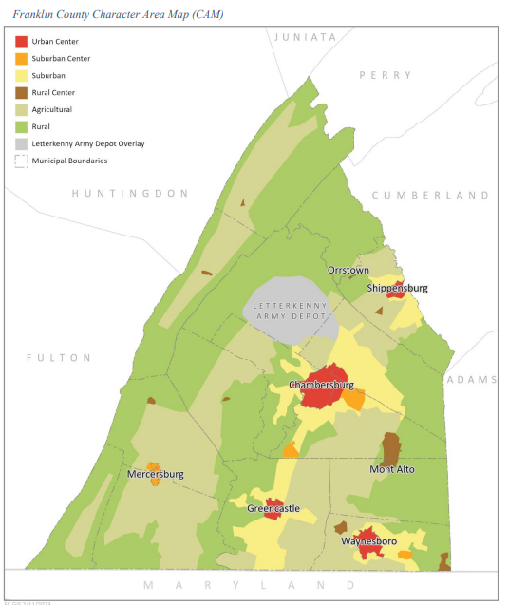
When Franklin County developed this map, they considered the following elements:
- The adjacent land uses of neighboring municipalities and counties have been considered and the CAM is generally consistent with proposed future land use plans in contiguous areas in Adams, Cumberland, Fulton, Huntingdon, Perry, and Juniata counties in Pennsylvania and Washington and Frederick counties in Maryland.
- Environmentally constrained areas such as steep slopes and floodplain have been incorporated, where relevant, into the Rural Resource areas of the CAM.
Washington County
When looking at Washington County which borders Montgomery Township to the south, the future land use types are again consistent with those of the Mercersburg Area. To the south the areas are agricultural and environmental conservation, with a portion of the area identified as a priority preservation area. The following is a summary of the land use types that border the Mercersburg Area in Washington County, Maryland:
- The agricultural policy area is highly desirable for agricultural preservation programs that have been overlain by the Preservation Policy area. The policy area primarily conforms to the Agricultural Rural zoning district but may also include preservation zoning districts in areas defined in that policy area. Currently, the Agricultural Rural zoning district restricts new residential development to one dwelling unit per 5 acres.
- The Environmental Conservation Policy area has been applied to areas of the County that contain multiple sensitive areas including steep slopes, floodplains, wetlands, streams, habitats of threatened and endangered species, forested areas, and wellhead protection areas.
- Preservation priority areas is policy area is the primary tool used to implement land preservation efforts in the County. Included within this policy areas are delineated Priority Preservation Areas (PPAs) including Rural Legacy areas. PPAs are required to be delineated by local jurisdictions to maintain a certified land preservation program and the significant funding ratios associated with said certification.
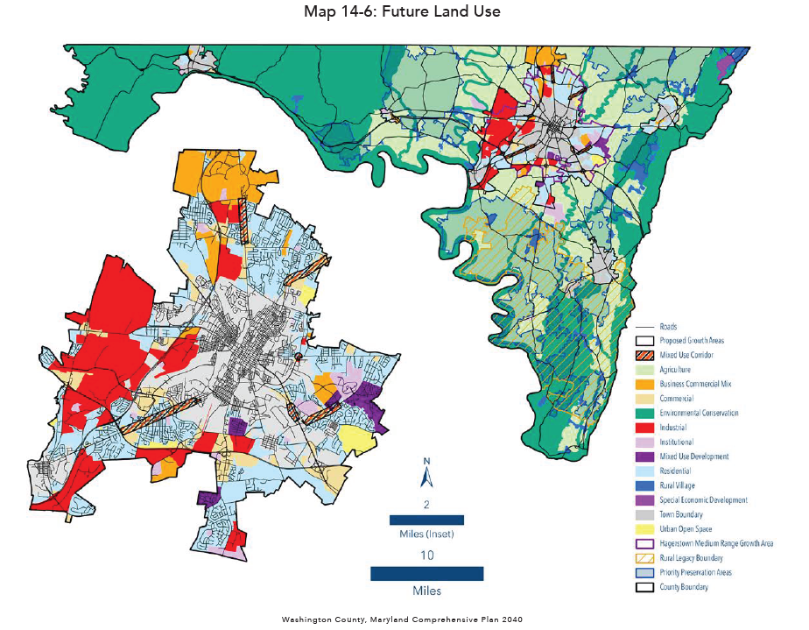
Fulton County
Similar to the other municipalities and Counties, the land uses identified in the Fulton County Comprehensive Plan are compatible and similar in nature to those that are within the Mercersburg Area. As noted Peters Township borders Ayr and Todd Townships in Fulton County. These areas are identified as rural, landscape, preserve open space and restricted open space. The Comprehensive Plan states that the rural resource areas of their growth management plan are “Identify, preserve, protect, enhance, and restore those areas that should remain rural and place them in a rural resource area. Rather than looking at the rural lands of the region as holding areas for future development, the region has identified these areas as built communities. Minimal growth will occur in this area, but the main intent will be to protect the rural landscape”. The following is a brief description of each land use type:
- Preserve Open Space - This classification shall consist of open space that is protected from development in perpetuity. The classification shall consist of the following:
  - Federally or State-Owned Lands
  - Surface Waterbodies
  - Protected Wetlands
  - Riparian Corridors
  - Purchased Open Space
  - Conservation Easements
  - Residual to Cluster Open Space
  - Transportation Corridors
- Restricted Open Space -The restricted open space classification consists of open space that falls within the transitional area between preserved open space and rural residential classifications. The intent of this classification is to provide protection for the lands that falls within this classification. The classification shall consist of the following:
  - Flood Plain
  - Steep Slopes
  - Prime Farmlands
  - Viewsheds
  - Recharge Areas for Groundwater Supplies
  - Mining or Mineral Extraction Sites
  - Natural Diversity Areas
  - Carbonate Geology Areas
  - Historic Structures
- Rural Landscape – is about 67.2% of land area in Fulton County. The rural residential classification shall be assigned to those locations that lend themselves to larger lot low density residential and open space land uses. The classification shall consist of the following:
  - Low Density Residential
  - Woodlands
  - Farmlands
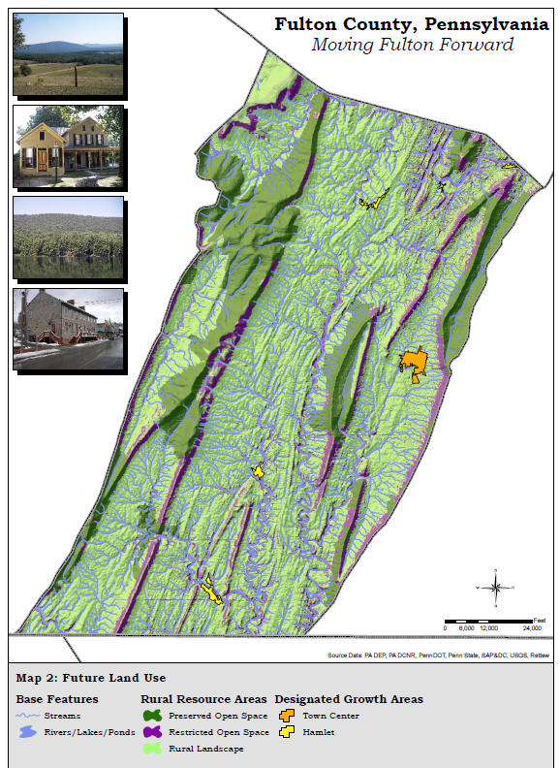
Consistency
When looking at the Mercersburg Area, and the surrounding communities, the land uses both current and future are compatible with one another. The surrounding communities have a large focus on natural and rural resources, and protection and conservation of these landscapes.

